Jyle Darling

M093437

DataBase Demonstration

AT1.6

Table of Contents

Connection String 1

Database Deployment 2

Application code 2

File Import 3

# Connection String

In order for an application to send queries and retrieve results from a database, the application must connect to the database via a specific string. This string must address the database location, a username and any passwords in order to connect to the database.

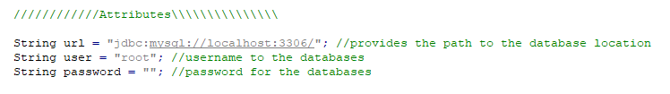

Once these parameters have been declared and assign a value, the connection to the database can be made by creating a connection object.



The variable declared as ‘statement’ in the above image is used to send various queries to the database.

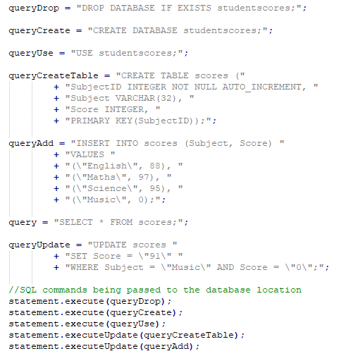

# Database Deployment

## Application code

Deploying a database can be done a number of ways. For this demonstration we will use PHPMyAdmin.

Databases and their tables can be created using written code, and implemented via written code connecting to a database via a connection script, or directly imported into the database by importing a .sql file.

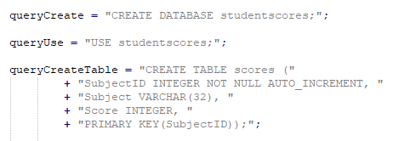

In the above image we can see that first a database is created named “studentscores”

We then tell the database that we wish to use the newly created table.

Next we create the table columns and assign their data types.

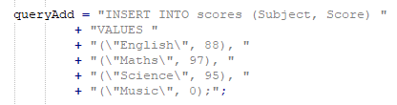

We can then add items to the newly created table by specifying the table columns we will be adding to, and then declaring the values that will be inserted into the specified table columns.

## File Import

The Process is quite similar for importing a .sql file directly into the database management system.

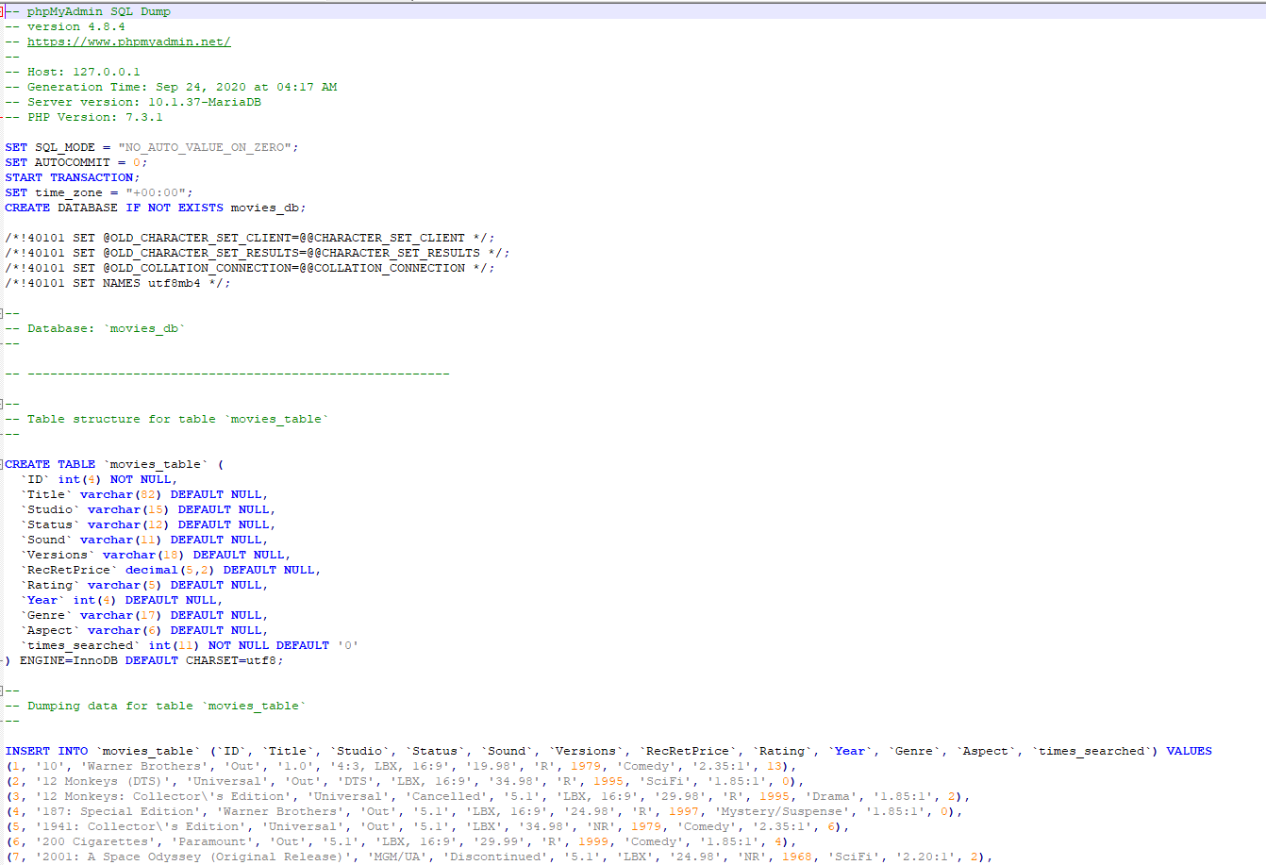

Above is a document that was created by exporting a created database to a .sql file. To create this database in PHPMyAdmin, first we need to create the database name. (movies_db) The .sql file can also be written to it will create the database, but for this example we will create the database name ourselves.

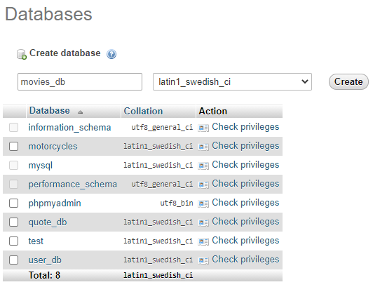

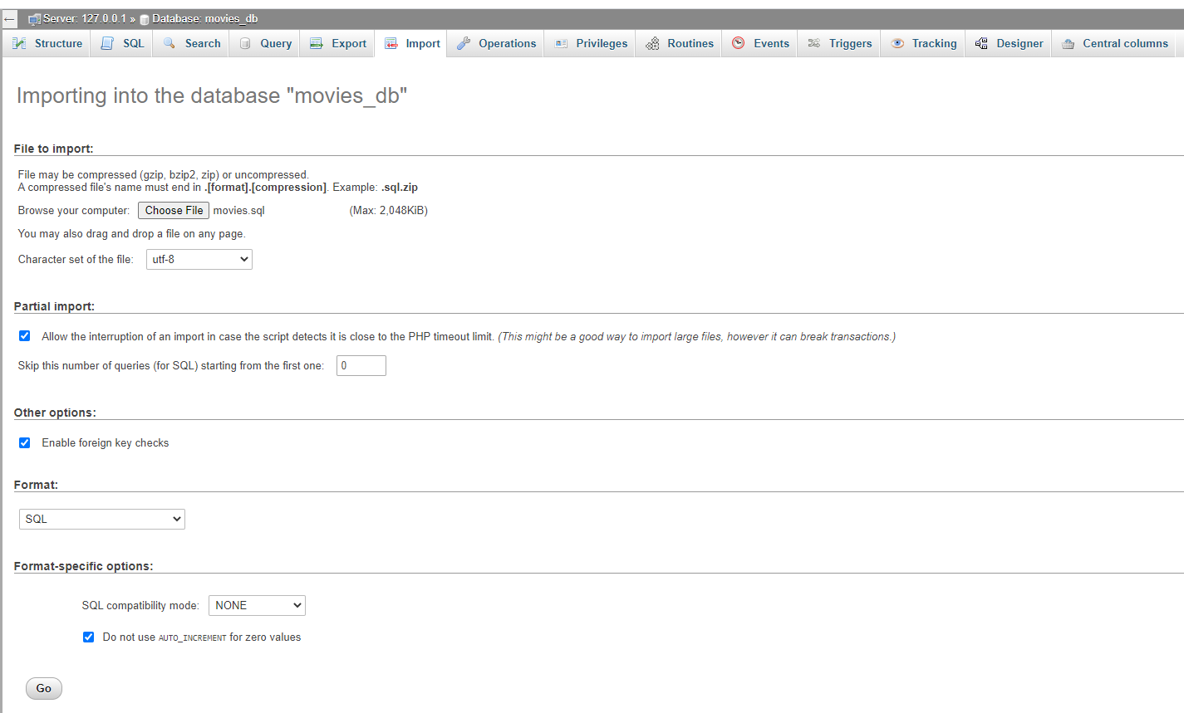

We then select the ‘Import’ tab and choose the appropriate .sql file, and after pressing the go button at the bottom of the page

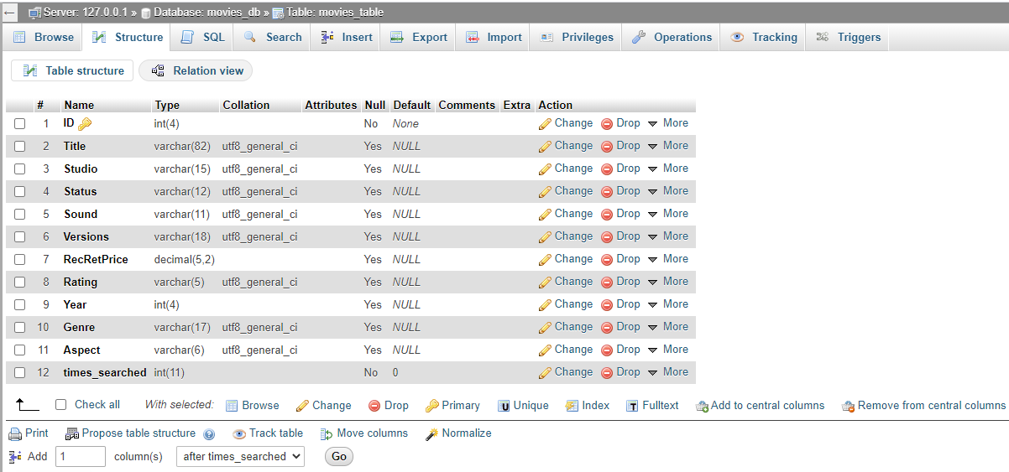

We can now see that a table movies_table was and the table columns along with their data types have been created.

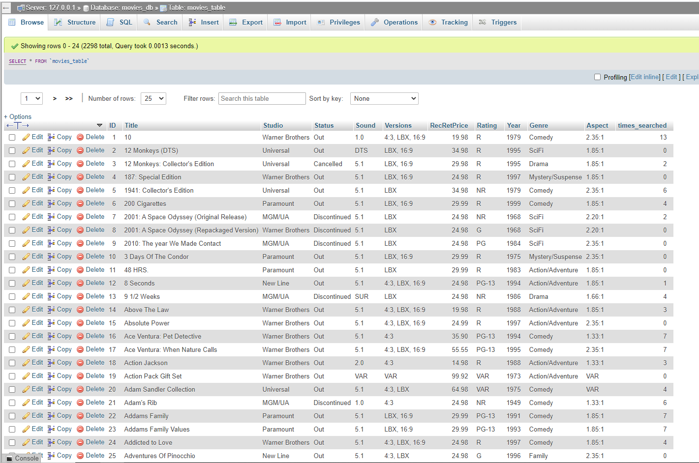

Clicking on browse we can see that the file has imported around 2300 table entries.

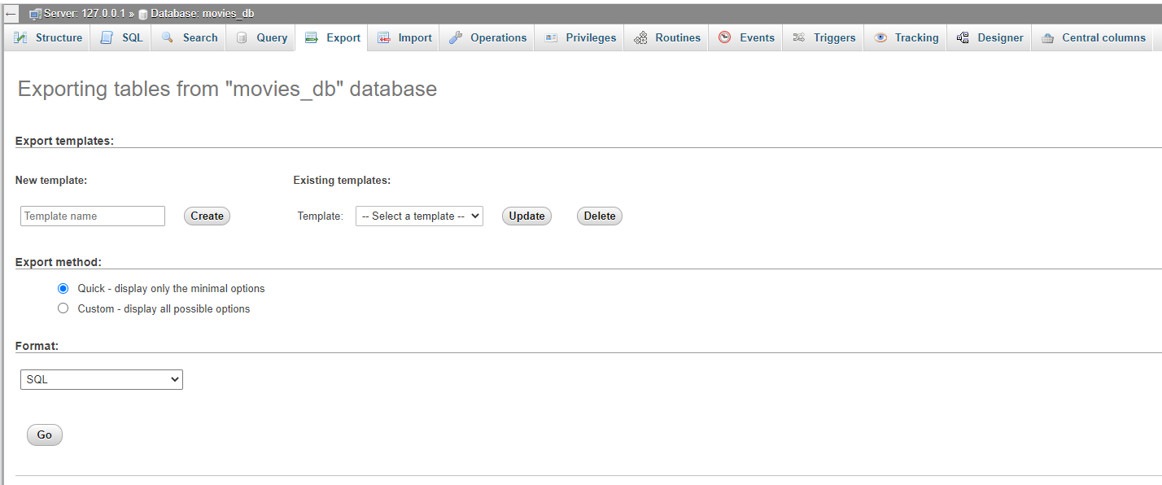

In order to easily send this database we can click on the export tab up the top, select SQL as the file format, then press the go button, which will produce a file like the one we used to import all the entries of the database.